CSA0208-C Programming
Automobile Service Centre Management System
SUBMITTED BY:
ISKA VARSHINI(192320011)
S PAVITHRASHA(192320016)
T LAKSHMI PRASANNA(192525207)

1. Problem Statement
The automobile industry is a major service-oriented sector where regular vehicle maintenance and servicing are essential for ensuring vehicle safety and customer satisfaction. Automobile service centres manage a large amount of information, including customer details, vehicle numbers, vehicle models, service types, service dates, replacement parts, labour charges, and total billing information. In many small and medium-sized service centres, these records are still maintained manually using notebooks, registers, and paper documents.
Maintaining records manually creates several difficulties. Searching for a specific vehicle record becomes time-consuming as the number of customers increases. Updating records manually can result in incorrect or overwritten information. Calculating parts costs, labour charges, and total bills manually may also cause billing errors. Physical records can be lost, damaged, or become difficult to manage over time. Preparing daily service reports or identifying vehicles with high service costs also requires additional manual effort.
To overcome these problems, an Automobile Service Centre Management System is proposed using the C programming language. The system provides a simple menu-driven interface for managing vehicle service records digitally. It stores important details such as vehicle number, customer name, vehicle model, service type, service date, parts cost, labour cost, and total service cost.
The system uses structures to organize related vehicle and service information into individual records. Pointers to structures are used for performing operations such as updating records and calculating service costs efficiently. The application allows users to register vehicles, search for records using vehicle numbers, update service details, calculate total bills, sort records based on service cost, display vehicles exceeding a specified service-cost limit, and generate daily service summaries.
File handling is also implemented to provide permanent storage of service records. Records can be saved to a file and automatically loaded when the application is started again. This eliminates the need to enter previously stored information repeatedly.
The system also includes various validation and error-handling mechanisms to improve reliability. Duplicate vehicle numbers are identified to prevent repeated records. Negative values for parts and labour costs are rejected as invalid inputs. Service dates are validated to ensure that months, days, and calendar values are correct. The system also checks the maximum record capacity to prevent array overflow. File operations are verified to ensure that files are successfully opened before reading or writing data.
Thus, the Automobile Service Centre Management System demonstrates the practical application of important C programming concepts such as structures, pointers, arrays, functions, searching, sorting, file handling, data validation, and error handling. By replacing manual record maintenance with a computerized approach, the system improves the speed, accuracy, reliability, and overall efficiency of automobile service record management.
.
2. Objective
The primary objective of this project is to design and develop a computerized Automobile Service Centre Management System using the C programming language. The system is intended to replace traditional manual service registers with an organized, efficient, and reliable digital method for managing automobile service records.
The specific objectives of the proposed system are:
1. To Digitize Vehicle Service Records
To store customer, vehicle, service, date, and billing information electronically instead of using manual registers.
2. To Demonstrate the Use of Structures
To use structures for organizing different types of related data, including character and numerical information, into a single service record.
3. To Demonstrate the Use of Pointers to Structures
To use structure pointers for efficiently accessing, updating, and processing service records without unnecessary data copying.
4. To Calculate Service Bills Automatically
To automatically calculate the total service cost by combining parts and labour charges, thereby reducing billing errors.
5. To Register New Vehicles
To provide a facility for entering and storing new customer and vehicle service details.
6. To Search Vehicle Records Efficiently
To allow users to quickly find service records by entering the vehicle number.
7. To Update Existing Records
To enable users to modify service details such as service type, parts cost, labour cost, and other information whenever required.
8. To Sort Records Based on Service Cost
To arrange service records according to their total service cost, making it easier to identify high-value services.
9. To Identify High-Cost Services
To display vehicles whose total service cost exceeds a user-specified amount, helping in service-cost analysis.
10. To Generate Daily Service Summaries
To generate service summaries for a selected date, including the number of vehicles serviced and the total revenue generated.
11. To Store Records Permanently
To use file handling to save service records permanently and prevent data loss when the program is closed.
12. To Load Previous Records Automatically
To retrieve previously stored service records from the file when the application starts.
13. To Handle Invalid Inputs and Errors
To validate duplicate vehicle numbers, negative costs, invalid dates, file errors, record limits, and other invalid conditions.
14. To Develop a User-Friendly Menu-Driven System
To provide a simple menu-based interface that allows users to perform different operations easily.
Overall Objective
The overall objective of the project is to develop a functional and reliable service management application while demonstrating the practical use of important C programming concepts, including structures, pointers, arrays, functions, searching, sorting, file handling, validation, and error handling in a real-world application.

3. Requirements and Environment Used
The Automobile Service Centre Management System is developed using the C programming language. The project requires a standard computer, a C compiler, and a suitable development environment for writing, compiling, executing, testing, and debugging the application.
Hardware Requirements
The minimum hardware requirements for running and developing the application are:
- Computer or laptop
- Minimum 4 GB RAM
- At least 1 GB of free storage
- Standard keyboard and display
- Any modern processor capable of running a C compiler
Since the application is a console-based C program, it requires only basic processing power and memory and does not need high-end hardware.
Software Requirements
The software requirements include:
- Programming Language: C
- Compiler: GCC or MinGW GCC
- Operating System: Windows, Linux, or macOS
- Development Environment: Visual Studio Code, Code::Blocks, Dev-C++, or any compatible C IDE
- Header Files: stdio.h, string.h, and ctype.h
Programming Environment
The program can be compiled using GCC with the following command:
gcc automobile_service.c -o automobile_service
After successful compilation, the application can be executed using:
automobile_service
The system is designed as a console application, so it does not require external database software or GUI frameworks.
Data Storage Requirement
The application uses a binary file named service_records.dat to store service records permanently. Binary file storage allows the complete structure to be efficiently written and retrieved using the standard C functions fwrite() and fread().
Maximum Record Capacity
The system supports a maximum of 100 service records. This limit is suitable for an academic project and allows the application to handle a moderate amount of data without requiring dynamic memory allocation.
The maximum capacity can be increased or modified in the future according to the requirements of the service centre.
4. Design / Proposed Solution
The proposed Automobile Service Centre Management System follows a modular, menu-driven approach. The application is divided into separate functions, with each function responsible for a specific operation. This improves readability, simplifies debugging, supports easier maintenance, and allows different modules to be developed and tested independently.
4.1 Data Representation
Each vehicle service is represented using a structure called ServiceRecord. It stores information related to the customer, vehicle, service details, and service charges.
The structure contains:
- Vehicle Number
- Customer Name
- Vehicle Model
- Service Type
- Service Date
- Parts Cost
- Labour Cost
- Total Service Cost
A separate Date structure stores the day, month, and year. This makes date validation and date-based operations easier.
The data can be conceptually organized as:
ServiceRecord
- Vehicle Number
- Customer Name
- Vehicle Model
- Service Type
- Service Date
  - Day
  - Month
  - Year
- Parts Cost
- Labour Cost
- Total Service Cost
4.2 Record Storage
During program execution, all service records are stored in an array of ServiceRecord structures.
The maximum capacity is defined as:
MAX_RECORDS = 100
A variable named count keeps track of the number of records currently stored.
The records are maintained as:
records[0]
records[1]
records[2]
...
records[count - 1]
Before adding a new record, the system checks whether the maximum capacity has been reached.
4.3 Vehicle Registration Module
The registration module is responsible for adding new vehicle service records.
The module performs the following steps:
- Checks the available record capacity.
- Accepts the vehicle number.
- Converts the vehicle number to uppercase.
- Checks whether the vehicle number already exists.
- Accepts customer details.
- Accepts vehicle and service information.
- Validates the service date.
- Accepts and validates the parts cost.
- Accepts and validates the labour cost.
- Calculates the total service cost.
- Stores the completed record in the array.
This process prevents duplicate and invalid information from being stored.
4.4 Searching Module
The searching module uses the vehicle number as the unique identifier.
A linear search is performed through the available records. The entered vehicle number is compared with each stored vehicle number using the strcmp() function.
If a matching record is found, its position is returned. If no match is found, the function returns -1.
4.5 Pointer-Based Calculation Module
The total service cost is calculated using a pointer to a structure.
The calculation is:
Total Service Cost = Parts Cost + Labour Cost
The address of the ServiceRecord structure is passed to the calculation function. The pointer accesses the structure members directly using the arrow (->) operator.
This avoids unnecessary copying of the complete structure and allows the calculated value to be stored directly in the original record.
4.6 Updating Module
The update module first searches for the required vehicle using its vehicle number.
When the record is found, its address is passed to the update function. The function then modifies the required information directly through a structure pointer.
If the parts cost or labour cost is changed, the total service cost is recalculated automatically.
4.7 Sorting Module
The system uses Insertion Sort to arrange service records according to their total service cost.
The records are sorted in descending order, so the vehicle with the highest service cost appears first.
This makes it easier to identify high-value service transactions.
4.8 High-Cost Analysis Module
The user can enter a specific service-cost threshold.
The system compares the total service cost of every record with the given amount.
If:
Total Service Cost > Specified Amount
the corresponding vehicle information is displayed.
This feature helps identify vehicles that require expensive repairs or services.
4.9 Daily Summary Module
The user can enter a particular service date. The system checks all stored records and identifies the records matching that date.
For the selected date, the system calculates:
- Number of vehicles serviced
- Total service revenue
The results are displayed as a daily service summary.
4.10 File Handling Module
File handling is used to provide permanent storage of service records.
When the application starts:
Load Records → File
When the user saves the records or exits the application:
Save Records → File
Before performing any file operation, the program checks whether the file was opened successfully.
The record count read from the file is also validated to prevent invalid memory or array access caused by corrupted data.
4.11 Error Handling Module
The system handles several possible errors, including:
- Duplicate vehicle numbers
- Negative service costs
- Invalid dates
- Invalid menu choices
- Maximum record capacity
- Missing data files
- Invalid or corrupted record counts
These validation mechanisms improve the reliability and safety of the application.
Overall System Flow
The overall operation of the system can be summarized as:
START
↓
Load Previous Records
↓
Display Main Menu
↓
User Selects an Operation
↓
Perform Selected Function
↓
Return to Main Menu
↓
Exit Selected?
- No → Return to Menu
- Yes → Save Records
↓
END
This modular structure makes the system easier to understand, test, maintain, and extend.
5. Algorithm / Pseudocode
5.1 Main Algorithm
- Start the program.
- Declare an array of ServiceRecord structures.
- Initialize the record count to zero.
- Load previously stored records from the file.
- Display the main menu.
- Accept the user's choice.
- Execute the selected operation.
- Return to the main menu.
- If the user selects Exit, save all records to the file.
- Terminate the program.
5.2 Registration Algorithm
- Check whether the maximum record capacity has been reached.
- If the capacity is full, display an error and return.
- Accept the vehicle number.
- Convert the vehicle number to uppercase.
- Search for an existing record with the same vehicle number.
- If a duplicate is found, display an error and cancel registration.
- Accept the customer name.
- Accept the vehicle model.
- Accept the service type.
- Enter the service date.
- Validate the date.
- If the date is invalid, request it again.
- Enter the parts cost.
- Reject the value if it is negative.
- Enter the labour cost.
- Reject the value if it is negative.
- Calculate the total service cost.
- Store the record in the array.
- Increase the record count.
- Display a successful registration message.
5.3 Search Algorithm
- Enter the vehicle number.
- Convert it to uppercase.
- Start searching from the first record.
- Compare the entered vehicle number with the current record.
- If a match is found, return the record position.
- Continue until all records have been checked.
- If no match is found, return -1.
5.4 Total Bill Calculation Algorithm
- Receive a pointer to the service record.
- Access the parts cost using the pointer.
- Access the labour cost using the pointer.
- Add both values.
- Store the result in total service cost.
- Return to the calling function.
Formula:
Total Service Cost = Parts Cost + Labour Cost
5.5 Update Algorithm
- Enter the vehicle number.
- Search for the corresponding vehicle.
- If the vehicle is not found, display an error message.
- If found, obtain the address of the record.
- Pass the record address to the update function.
- Enter the updated customer, vehicle, and service details.
- Validate the date and cost values.
- Recalculate the total service cost.
- Display an update-success message.
5.6 Sorting Algorithm
The system uses Insertion Sort to arrange records by service cost.
- Start from the second record.
- Store the current record as the key.
- Compare the key with the previous records.
- If a previous record has a lower service cost, move it forward.
- Continue until the correct position is found.
- Insert the key at that position.
- Repeat until all records are processed.
The final result is a list arranged from the highest service cost to the lowest.
5.7 Daily Summary Algorithm
- Enter the required service date.
- Validate the date.
- Set the vehicle count to zero.
- Set total revenue to zero.
- Compare the selected date with every service record.
- If the dates match, increase the vehicle count.
- Add the service cost to the total revenue.
- Continue until all records are checked.
- Display the number of vehicles serviced.
- Display the total revenue.
5.8 Flowchart
The logical flow of the system is:
START
↓
Load Previous Records
↓
Display Main Menu
↓
User Choice
↓
Register / Search / Update / Other Operations
↓
Perform Selected Operation
↓
Return to Menu
↓
Exit Selected?
→ No: Display Menu Again
→ Yes: Save File
↓
END
6. Implementation / Source Code Explanation
The Automobile Service Centre Management System is implemented in C as a menu-driven console application. A modular programming approach is followed, where different operations are implemented as separate functions. This improves code readability, maintainability, testing, and debugging.
The major C programming concepts used in the implementation include:
- Structures
- Nested structures
- Arrays of structures
- Pointers to structures
- Functions
- String handling
- Searching
- Sorting
- File handling
- Input validation
- Runtime error handling
During execution, service records are maintained in memory and can be permanently stored in a binary file. When the application starts, previously saved records are loaded automatically, allowing data to remain available across multiple executions.
6.1 Header Files Used
The implementation uses the following header files:
- stdio.h
- string.h
- ctype.h
stdio.h
The stdio.h header provides standard input/output and file-handling functions such as:
- printf()
- scanf()
- fgets()
- fopen()
- fread()
- fwrite()
- fclose()
string.h
The string.h header provides string manipulation functions such as:
- strcmp()
- strcspn()
These functions are used for comparing vehicle numbers and removing newline characters obtained through fgets().
ctype.h
The ctype.h header provides character-processing functions.
The toupper() function is used to convert vehicle numbers into uppercase. This ensures that differences in letter case do not result in duplicate records.
For example:
tn01ab1234
TN01AB1234
Tn01Ab1234
are all converted to:
TN01AB1234
This improves the accuracy of searching and duplicate detection.
6.2 Constants Used
The program defines constants for the maximum record capacity and file name:
#define MAX_RECORDS 100
#define FILE_NAME "service_records.dat"
MAX_RECORDS specifies the maximum number of service records that can be stored in the array.
FILE_NAME provides a fixed name for the data file, making it easier to modify the file name in the future.
6.3 Date Structure
A separate structure is used to store service dates:
typedef struct {
int day;
int month;
int year;
} Date;
Using a separate Date structure keeps the program organized. Instead of storing a complete date as one string, the day, month, and year are stored separately.
This provides several benefits:
- Easier date comparison
- Easier date validation
- Simplified daily-summary generation
- Support for leap-year validation
- Clearer data organization
6.4 Main ServiceRecord Structure
The primary structure used by the system is ServiceRecord.
It contains:
- vehicleNumber
- customerName
- vehicleModel
- serviceType
- serviceDate
- partsCost
- labourCost
- totalServiceCost
The structure stores all important information related to a vehicle service.
Vehicle Number
The vehicle number acts as the unique identifier of the service record.
Example:
TN01AB1234
The system prevents duplicate vehicle numbers.
Customer Name
Stores the name of the vehicle owner or customer.
Vehicle Model
Stores the model of the vehicle.
Examples:
- Hyundai i20
- Honda City
- Tata Nexon
Service Type
Stores the type of service performed.
Examples include:
- General Service
- Engine Repair
- Oil Change
- Brake Service
- Full Service
Service Date
The nested Date structure stores the day, month, and year of the service.
Parts Cost
Stores the total cost of parts used during servicing.
Labour Cost
Stores the charges for labour or technician services.
Total Service Cost
The total amount is calculated automatically using:
Total Service Cost = Parts Cost + Labour Cost
6.5 Function-Based Program Design
The program is divided into several functions, including:
- convertToUpper()
- clearInputBuffer()
- isValidDate()
- isDuplicate()
- searchVehicle()
- calculateTotal()
- registerVehicle()
- displayRecord()
- displayAll()
- updateServiceRecord()
- updateVehicle()
- calculateBill()
- sortByServiceCost()
- displayHighCostVehicles()
- generateDailySummary()
- saveRecords()
- loadRecords()
Each function performs a specific operation within the system.
The modular design provides several advantages:
- Easier debugging
- Better code organization
- Easier maintenance
- Code reusability
- Simplified testing
- Clear separation of responsibilities among team members
6.6 Complete C Program
/**
* =====================================================================================
* Automobile Service Centre Management System
* Course Outcomes: CO 3, CO 4 & CO 5 (Bloom's Levels 3, 4, 5 & 6)
* Language: C (C99 Standard)
* =====================================================================================
*/

#include <stdio.h>
#include <stdlib.h>
#include <string.h>
#include <ctype.h>
#include <stdbool.h>

#define MAX_RECORDS 100
#define STR_LEN 50
#define FILE_NAME "service_records.dat"

/* =====================================================================================
* STRUCTURE DEFINITIONS
* Requirement (a): Structure for Date and Vehicle Service Record
* =====================================================================================
*/

typedef struct {
int day;
int month;
int year;
} Date;

typedef struct {
char vehicle_number[20];
char customer_name[STR_LEN];
char vehicle_model[STR_LEN];
char service_type[STR_LEN];
Date service_date;
double parts_cost;
double labour_cost;
double total_service_cost;
} VehicleService;

/* =====================================================================================
* FUNCTION DECLARATIONS
* =====================================================================================
*/

// Core Utility & Pointer Functions - Requirement (b)
void calculate_total_cost(VehicleService *record);
void update_service_record(VehicleService *record, const char *new_model, const char *new_service_type,
Date new_date, double new_parts_cost, double new_labour_cost);

// Validation Functions - Requirement (d)
bool is_leap_year(int year);
bool is_valid_date(Date date);
bool is_valid_cost(double cost);
int search_vehicle_index(const VehicleService records[], int count, const char *vnum);
void to_upper_str(char *str);
void read_string(const char *prompt, char *buffer, int max_len);
double read_double(const char *prompt);
Date read_date(const char *prompt);

// Menu Core Features - Requirement (c)
void register_vehicle(VehicleService records[], int *count);
void search_vehicle_menu(const VehicleService records[], int count);
void update_vehicle_menu(VehicleService records[], int count);
void calculate_bill_menu(const VehicleService records[], int count);
void sort_vehicles_by_cost(VehicleService records[], int count);
void display_high_cost_vehicles(const VehicleService records[], int count);
void generate_daily_summary(const VehicleService records[], int count);
int save_records_to_file(const VehicleService records[], int count, const char *filename);
int load_records_from_file(VehicleService records[], int *count, const char *filename);

// Helper Display Functions
void print_header(void);
void print_record(const VehicleService *rec, int index);
void quick_sort_records(VehicleService records[], int low, int high);
int partition(VehicleService records[], int low, int high);

/* =====================================================================================
* IMPLEMENTATION: POINTER & COST CALCULATION FUNCTIONS
* Requirement (b): Pointer-based record modification and cost computation
* =====================================================================================
*/

/**
* Calculates total service cost using pointer to VehicleService structure.
* Total Cost = Parts Cost + Labour Cost
*/
void calculate_total_cost(VehicleService *record) {
if (record != NULL) {
record->total_service_cost = record->parts_cost + record->labour_cost;
}
}

/**
* Updates an existing vehicle service record in-place via structure pointer.
*/
void update_service_record(VehicleService *record, const char *new_model, const char *new_service_type,
Date new_date, double new_parts_cost, double new_labour_cost) {
if (record == NULL) return;

if (new_model && strlen(new_model) > 0) {
strncpy(record->vehicle_model, new_model, sizeof(record->vehicle_model) - 1);
record->vehicle_model[sizeof(record->vehicle_model) - 1] = '\0';
}
if (new_service_type && strlen(new_service_type) > 0) {
strncpy(record->service_type, new_service_type, sizeof(record->service_type) - 1);
record->service_type[sizeof(record->service_type) - 1] = '\0';
}
record->service_date = new_date;
record->parts_cost = new_parts_cost;
record->labour_cost = new_labour_cost;

// Recalculate total cost automatically after updating components
calculate_total_cost(record);
}

/* =====================================================================================
* IMPLEMENTATION: VALIDATION & INPUT HELPERS
* Requirement (d): Validation logic for Dates, Costs, Strings, and Edge Cases
* =====================================================================================
*/

bool is_leap_year(int year) {
return ((year % 4 == 0 && year % 100 != 0) || (year % 400 == 0));
}

bool is_valid_date(Date date) {
if (date.year < 2000 || date.year > 2100) return false;
if (date.month < 1 || date.month > 12) return false;

int days_in_month[] = {0, 31, 28, 31, 30, 31, 30, 31, 31, 30, 31, 30, 31};
if (date.month == 2 && is_leap_year(date.year)) {
days_in_month[2] = 29;
}

return (date.day >= 1 && date.day <= days_in_month[date.month]);
}

bool is_valid_cost(double cost) {
return cost >= 0.0;
}

void to_upper_str(char *str) {
for (int i = 0; str[i]; i++) {
str[i] = (char)toupper((unsigned char)str[i]);
}
}

void read_string(const char *prompt, char *buffer, int max_len) {
printf("%s", prompt);
if (fgets(buffer, max_len, stdin) != NULL) {
size_t len = strlen(buffer);
if (len > 0 && buffer[len - 1] == '\n') {
buffer[len - 1] = '\0';
} else {
// Clear standard input buffer if string exceeded max_len
int c;
while ((c = getchar()) != '\n' && c != EOF);
}
}
}

double read_double(const char *prompt) {
double val;
char buffer[100];
while (1) {
printf("%s", prompt);
if (fgets(buffer, sizeof(buffer), stdin) != NULL) {
if (sscanf(buffer, "%lf", &val) == 1 && is_valid_cost(val)) {
return val;
}
}
printf(" Error: Invalid cost! Please enter a non-negative number.\n");
}
}

Date read_date(const char *prompt) {
Date date;
char buffer[100];
while (1) {
printf("%s", prompt);
if (fgets(buffer, sizeof(buffer), stdin) != NULL) {
if (sscanf(buffer, "%d-%d-%d", &date.day, &date.month, &date.year) == 3 ||
sscanf(buffer, "%d/%d/%d", &date.day, &date.month, &date.year) == 3) {
if (is_valid_date(date)) {
return date;
}
}
}
printf(" Error: Invalid date! Please use DD-MM-YYYY format (Year 2000-2100).\n");
}
}

int search_vehicle_index(const VehicleService records[], int count, const char *vnum) {
char target[20];
strncpy(target, vnum, sizeof(target) - 1);
target[sizeof(target) - 1] = '\0';
to_upper_str(target);

for (int i = 0; i < count; i++) {
char current[20];
strncpy(current, records[i].vehicle_number, sizeof(current) - 1);
current[sizeof(current) - 1] = '\0';
to_upper_str(current);
if (strcmp(current, target) == 0) {
return i;
}
}
return -1;
}

/* =====================================================================================
* MENU FUNCTIONALITIES
* Requirement (c): Register, Search, Update, Calculate, Sort, Filter, Summary, File I/O
* =====================================================================================
*/

/**
* 1. Register a new vehicle for service.
* Handles Duplicate Vehicle Check and Array Capacity Limit.
*/
void register_vehicle(VehicleService records[], int *count) {
printf("\n--- REGISTER NEW VEHICLE ---\n");

// Check Maximum Record Capacity Requirement (d)
if (*count >= MAX_RECORDS) {
printf(" Error: Cannot register vehicle. System maximum capacity (%d) reached!\n", MAX_RECORDS);
return;
}

char vnum[20];
read_string("Enter Vehicle Number (e.g. KA01AB1234): ", vnum, sizeof(vnum));
to_upper_str(vnum);

// Check Duplicate Vehicle Requirement (d)
if (search_vehicle_index(records, *count, vnum) != -1) {
printf(" Error: Duplicate Registration! Vehicle Number '%s' is already registered.\n", vnum);
return;
}

VehicleService new_rec;
strncpy(new_rec.vehicle_number, vnum, sizeof(new_rec.vehicle_number) - 1);
new_rec.vehicle_number[sizeof(new_rec.vehicle_number) - 1] = '\0';

read_string("Enter Customer Name: ", new_rec.customer_name, sizeof(new_rec.customer_name));
read_string("Enter Vehicle Model (e.g. Honda City): ", new_rec.vehicle_model, sizeof(new_rec.vehicle_model));
read_string("Enter Service Type (e.g. Full Service, Oil Change): ", new_rec.service_type, sizeof(new_rec.service_type));

new_rec.service_date = read_date("Enter Service Date (DD-MM-YYYY): ");
new_rec.parts_cost = read_double("Enter Parts Cost (INR): ");
new_rec.labour_cost = read_double("Enter Labour Cost (INR): ");

// Use Pointer Function to calculate total cost
calculate_total_cost(&new_rec);

records[*count] = new_rec;
(*count)++;

printf(" Success: Vehicle '%s' registered successfully! Total Cost: INR %.2f\n",
new_rec.vehicle_number, new_rec.total_service_cost);
}

/**
* 2. Search for a vehicle by vehicle number.
*/
void search_vehicle_menu(const VehicleService records[], int count) {
printf("\n--- SEARCH VEHICLE RECORD ---\n");
if (count == 0) {
printf(" No vehicle records registered yet.\n");
return;
}

char vnum[20];
read_string("Enter Vehicle Number to Search: ", vnum, sizeof(vnum));
int idx = search_vehicle_index(records, count, vnum);

if (idx == -1) {
printf(" Search Result: Vehicle '%s' not found in system.\n", vnum);
} else {
printf("\nVehicle Record Found:\n");
print_header();
print_record(&records[idx], idx + 1);
}
}

/**
* 3. Update vehicle service details.
*/
void update_vehicle_menu(VehicleService records[], int count) {
printf("\n--- UPDATE SERVICE DETAILS ---\n");
if (count == 0) {
printf(" No vehicle records registered yet.\n");
return;
}

char vnum[20];
read_string("Enter Vehicle Number to Update: ", vnum, sizeof(vnum));
int idx = search_vehicle_index(records, count, vnum);

if (idx == -1) {
printf(" Error: Vehicle '%s' not found.\n", vnum);
return;
}

printf("\nCurrent Details for %s:\n", records[idx].vehicle_number);
print_header();
print_record(&records[idx], 1);

printf("\nEnter Updated Details:\n");
char new_model[STR_LEN];
char new_service_type[STR_LEN];
read_string("Enter New Vehicle Model: ", new_model, sizeof(new_model));
read_string("Enter New Service Type: ", new_service_type, sizeof(new_service_type));
Date new_date = read_date("Enter New Service Date (DD-MM-YYYY): ");
double new_parts = read_double("Enter New Parts Cost (INR): ");
double new_labour = read_double("Enter New Labour Cost (INR): ");

// Use Pointer Function to update service record
update_service_record(&records[idx], new_model, new_service_type, new_date, new_parts, new_labour);

printf(" Success: Vehicle service details updated successfully!\n");
}

/**
* 4. Calculate total bill for a specific vehicle.
*/
void calculate_bill_menu(const VehicleService records[], int count) {
printf("\n--- CALCULATE TOTAL BILL ---\n");
if (count == 0) {
printf(" No vehicle records registered yet.\n");
return;
}

char vnum[20];
read_string("Enter Vehicle Number for Invoice: ", vnum, sizeof(vnum));
int idx = search_vehicle_index(records, count, vnum);

if (idx == -1) {
printf(" Error: Vehicle '%s' not found.\n", vnum);
return;
}

const VehicleService *rec = &records[idx];
printf("\n==================================================\n");
printf(" AUTOMOBILE SERVICE INVOICE \n");
printf("==================================================\n");
printf(" Vehicle Number : %s\n", rec->vehicle_number);
printf(" Customer Name : %s\n", rec->customer_name);
printf(" Model : %s\n", rec->vehicle_model);
printf(" Service Type : %s\n", rec->service_type);
printf(" Service Date : %02d-%02d-%04d\n", rec->service_date.day, rec->service_date.month, rec->service_date.year);
printf("--------------------------------------------------\n");
printf(" Parts Cost : INR %10.2f\n", rec->parts_cost);
printf(" Labour Cost : INR %10.2f\n", rec->labour_cost);
printf("--------------------------------------------------\n");
printf(" TOTAL BILL : INR %10.2f\n", rec->total_service_cost);
printf("==================================================\n");
}

/* =====================================================================================
* SORTING ALGORITHM IMPLEMENTATION (QUICKSORT)
* Requirement (e): Fast sorting based on total service cost
* =====================================================================================
*/

int partition(VehicleService records[], int low, int high) {
double pivot = records[high].total_service_cost;
int i = low - 1;

for (int j = low; j < high; j++) {
// Sort in descending order of service cost
if (records[j].total_service_cost > pivot) {
i++;
VehicleService temp = records[i];
records[i] = records[j];
records[j] = temp;
}
}
VehicleService temp = records[i + 1];
records[i + 1] = records[high];
records[high] = temp;
return (i + 1);
}

void quick_sort_records(VehicleService records[], int low, int high) {
if (low < high) {
int pi = partition(records, low, high);
quick_sort_records(records, low, pi - 1);
quick_sort_records(records, pi + 1, high);
}
}

/**
* 5. Sort vehicles based on service cost.
*/
void sort_vehicles_by_cost(VehicleService records[], int count) {
printf("\n--- SORT VEHICLES BY SERVICE COST ---\n");
if (count == 0) {
printf(" No records available to sort.\n");
return;
}

quick_sort_records(records, 0, count - 1);
printf(" Success: Sorted %d vehicle record(s) by total service cost (Descending Order).\n\n", count);

print_header();
for (int i = 0; i < count; i++) {
print_record(&records[i], i + 1);
}
}

/**
* 6. Display vehicles whose service cost exceeds a specified amount.
*/
void display_high_cost_vehicles(const VehicleService records[], int count) {
printf("\n--- DISPLAY HIGH-COST SERVICES ---\n");
if (count == 0) {
printf(" No vehicle records available.\n");
return;
}

double threshold = read_double("Enter Service Cost Threshold (INR): ");
int matches = 0;

printf("\nVehicles with Service Cost Exceeding INR %.2f:\n", threshold);
print_header();
for (int i = 0; i < count; i++) {
if (records[i].total_service_cost > threshold) {
print_record(&records[i], matches + 1);
matches++;
}
}

if (matches == 0) {
printf(" No vehicles found exceeding the cost threshold of INR %.2f.\n", threshold);
} else {
printf("\n Found %d matching vehicle(s).\n", matches);
}
}

/**
* 7. Generate a daily service summary report.
*/
void generate_daily_summary(const VehicleService records[], int count) {
printf("\n--- GENERATE DAILY SERVICE SUMMARY REPORT ---\n");
if (count == 0) {
printf(" No records registered yet for summary generation.\n");
return;
}

Date target_date = read_date("Enter Target Summary Date (DD-MM-YYYY): ");
int daily_count = 0;
double total_revenue = 0.0;
double total_parts = 0.0;
double total_labour = 0.0;
double max_cost = -1.0;
char highest_paying_vnum[20] = "N/A";

printf("\nService Summary for Date: %02d-%02d-%04d\n", target_date.day, target_date.month, target_date.year);
print_header();

for (int i = 0; i < count; i++) {
if (records[i].service_date.day == target_date.day &&
records[i].service_date.month == target_date.month &&
records[i].service_date.year == target_date.year) {

print_record(&records[i], daily_count + 1);
daily_count++;
total_parts += records[i].parts_cost;
total_labour += records[i].labour_cost;
total_revenue += records[i].total_service_cost;

if (records[i].total_service_cost > max_cost) {
max_cost = records[i].total_service_cost;
strcpy(highest_paying_vnum, records[i].vehicle_number);
}
}
}

if (daily_count == 0) {
printf(" No services registered on date %02d-%02d-%04d.\n", target_date.day, target_date.month, target_date.year);
return;
}

printf("========================================================\n");
printf(" DAILY SUMMARY STATISTICS \n");
printf("========================================================\n");
printf(" Total Vehicles Serviced : %d\n", daily_count);
printf(" Total Parts Revenue : INR %10.2f\n", total_parts);
printf(" Total Labour Revenue : INR %10.2f\n", total_labour);
printf(" TOTAL DAILY REVENUE : INR %10.2f\n", total_revenue);
printf(" Average Service Cost : INR %10.2f\n", total_revenue / daily_count);
printf(" Highest Service Bill : INR %10.2f (Vehicle: %s)\n", max_cost, highest_paying_vnum);
printf("========================================================\n");
}

/* =====================================================================================
* FILE HANDLING IMPLEMENTATION & REDESIGN
* Requirement (c) & (f): Persistent binary file storage & graceful error handling
* =====================================================================================
*/

/**
* 8. Store service records into binary file safely.
*/
int save_records_to_file(const VehicleService records[], int count, const char *filename) {
FILE *fp = fopen(filename, "wb");
if (fp == NULL) {
printf(" Error (File I/O): Failed to open file '%s' for writing.\n", filename);
return 0;
}

// Write record count first
if (fwrite(&count, sizeof(int), 1, fp) != 1) {
printf(" Error (File I/O): Failed to write record header.\n");
fclose(fp);
return 0;
}

// Write all vehicle structures
size_t written = fwrite(records, sizeof(VehicleService), count, fp);
fclose(fp);

if (written != (size_t)count) {
printf(" Warning: Partial write occurred (%zu of %d records written).\n", written, count);
return 0;
}

printf(" Success: Saved %d service record(s) to '%s'.\n", count, filename);
return 1;
}

/**
* 9. Load previous records from file when application starts or upon request.
* Requirement (f): Graceful handling of missing files and corrupted data.
*/
int load_records_from_file(VehicleService records[], int *count, const char *filename) {
FILE *fp = fopen(filename, "rb");
if (fp == NULL) {
// File does not exist yet (Normal behavior on initial run)
*count = 0;
return 0;
}

int file_count = 0;
if (fread(&file_count, sizeof(int), 1, fp) != 1 || file_count < 0) {
printf(" Warning: Corrupted file header in '%s'. Starting with empty records.\n", filename);
fclose(fp);
*count = 0;
return 0;
}

if (file_count > MAX_RECORDS) {
printf(" Warning: File contains %d records, exceeding capacity (%d). Truncating.\n",
file_count, MAX_RECORDS);
file_count = MAX_RECORDS;
}

size_t read_cnt = fread(records, sizeof(VehicleService), file_count, fp);
fclose(fp);

*count = (int)read_cnt;
printf(" Success: Loaded %d previous service record(s) from '%s'.\n", *count, filename);
return 1;
}

/* =====================================================================================
* PRESENTATION HELPERS & DISPLAY TABLE
* =====================================================================================
*/

void print_header(void) {
printf("+----+------------+----------------------+-------------------+-------------------+------------+------------+------------+------------+\n");
printf("| S# | Veh Number | Customer Name | Vehicle Model | Service Type | Date | Parts(INR) | Labour(INR)| Total(INR) |\n");
printf("+----+------------+----------------------+-------------------+-------------------+------------+------------+------------+------------+\n");
}

void print_record(const VehicleService *rec, int index) {
printf("| %-2d | %-10s | %-20.20s | %-17.17s | %-17.17s | %02d-%02d-%04d | %10.2f | %10.2f | %10.2f |\n",
index, rec->vehicle_number, rec->customer_name, rec->vehicle_model,
rec->service_type, rec->service_date.day, rec->service_date.month,
rec->service_date.year, rec->parts_cost, rec->labour_cost, rec->total_service_cost);
printf("+----+------------+----------------------+-------------------+-------------------+------------+------------+------------+------------+\n");
}

/* =====================================================================================
* MAIN MENU & DRIVER SYSTEM
* Requirement (c): Menu-Driven Application
* =====================================================================================
*/

int main(void) {
VehicleService records[MAX_RECORDS];
int record_count = 0;

printf("=====================================================================================\n");
printf(" AUTOMOBILE SERVICE CENTRE MANAGEMENT SYSTEM (C-BASED) \n");
printf("=====================================================================================\n");

// Automatically load previous records on application start - Requirement (c) & (f)
load_records_from_file(records, &record_count, FILE_NAME);

int choice;
char choice_buf[50];

while (1) {
printf("\n=====================================================================================\n");
printf(" MAIN MENU \n");
printf("=====================================================================================\n");
printf(" 1. Register a Vehicle for Service\n");
printf(" 2. Search Vehicle by Vehicle Number\n");
printf(" 3. Update Service Details\n");
printf(" 4. Calculate Total Bill (Generate Invoice)\n");
printf(" 5. Sort Vehicles based on Service Cost (QuickSort)\n");
printf(" 6. Display Vehicles Exceeding Specified Cost Threshold\n");
printf(" 7. Generate Daily Service Summary Report\n");
printf(" 8. Store Service Records to File\n");
printf(" 9. Reload Previous Records from File\n");
printf(" 0. Save & Exit Application\n");
printf("=====================================================================================\n");
printf("Enter your choice (0-9): ");

if (fgets(choice_buf, sizeof(choice_buf), stdin) == NULL) {
break;
}

if (sscanf(choice_buf, "%d", &choice) != 1) {
printf(" Error: Invalid choice! Please enter a number between 0 and 9.\n");
continue;
}

switch (choice) {
case 1:
register_vehicle(records, &record_count);
break;
case 2:
search_vehicle_menu(records, record_count);
break;
case 3:
update_vehicle_menu(records, record_count);
break;
case 4:
calculate_bill_menu(records, record_count);
break;
case 5:
sort_vehicles_by_cost(records, record_count);
break;
case 6:
display_high_cost_vehicles(records, record_count);
break;
case 7:
generate_daily_summary(records, record_count);
break;
case 8:
save_records_to_file(records, record_count, FILE_NAME);
break;
case 9:
load_records_from_file(records, &record_count, FILE_NAME);
break;
case 0:
printf("\nSaving records to '%s' before exit...\n", FILE_NAME);
save_records_to_file(records, record_count, FILE_NAME);
printf("Thank you for using Automobile Service Centre Management System. Goodbye!\n");
return 0;
default:
printf(" Error: Invalid choice! Please enter a number between 0 and 9.\n");
}
}

return 0;
}
6.7 Explanation of Pointer Usage
A key requirement of the assignment is to demonstrate the practical use of pointers to structures. In the proposed system, pointers are used to directly access and modify service records.
The function:
void calculateTotal(ServiceRecord *record)
receives the memory address of a ServiceRecord structure. The pointer refers directly to the original structure, allowing its members to be accessed and modified without creating a separate copy.
The structure members are accessed using the arrow operator (->):
record->partsCost
record->labourCost
record->totalServiceCost
The arrow operator is used because record is a pointer to a structure.
The function is called using:
calculateTotal(&newRecord);
Here, the address-of operator (&) passes the memory address of newRecord to the function.
The pointer-based approach provides several advantages:
- Avoids copying the entire structure.
- Allows direct modification of the original record.
- Reduces unnecessary memory usage.
- Improves efficiency when working with larger structures.
- Demonstrates the practical application of pointers in a real-world program.
The update operation also uses a pointer-based approach through the function:
void updateServiceRecord(ServiceRecord *record)
The function is called as:
updateServiceRecord(&records[index]);
As a result, any changes made inside the function are applied directly to the original service record stored in the array.
6.8 Implementation Summary
The implementation combines several important C programming concepts to satisfy the functional requirements of the Automobile Service Centre Management System.
C Concept | Application in the Project
Structures | Store complete vehicle service details
Nested Structures | Store service date information
Arrays | Maintain multiple service records
Pointers | Directly update and calculate service records
Functions | Provide modular program organization
Linear Search | Locate vehicle records using vehicle numbers
Insertion Sort | Arrange records according to service cost
File Handling | Provide permanent storage of records
Input Validation | Prevent invalid or incorrect data
Error Handling | Manage file, capacity, and input-related errors
Overall, the implementation successfully integrates the major programming concepts required by the assignment. It provides a structured approach to vehicle service management while demonstrating the practical application of structures, pointers, arrays, functions, searching, sorting, file handling, validation, and error handling in C.
7. Test cases with expected and actual results
Testing is an important stage in software development. After implementing the Automobile Service Centre Management System, different test scenarios were created to verify whether each function performs correctly.
The testing process focused on three major categories:
- Normal input conditions.
- High-cost service conditions.
- Invalid and error input conditions.
Additional test cases were also created for searching, updating, sorting, daily summaries, duplicate detection, and file persistence.
Test Case 1 – Normal Vehicle Service Registration
Purpose
To verify whether the system successfully registers a normal vehicle service record and calculates the correct total bill.
Input
Field | Input Value
Vehicle Number | TN01AB1234
Customer Name | Sahana
Vehicle Model | Hyundai i20
Service Type | General Service
Service Date | 02 09 2026
Parts Cost | 1500
Labour Cost | 800
Expected Result
The vehicle record should be stored successfully.
The total service cost should be:
1500 + 800 = Rs. 2300
Actual Result
Vehicle registered successfully!
Total Service Cost: Rs. 2300.00
Status
PASS
Test Case 2 – High-Cost Vehicle Service
Purpose
To verify the calculation and identification of an expensive vehicle service.
Input
Field | Input Value
Vehicle Number | TN10XY9876
Customer Name | Arun Kumar
Vehicle Model | Honda City
Service Type | Engine Repair
Service Date | 02 09 2026
Parts Cost | 45000
Labour Cost | 15000
Expected Result
45000 + 15000 = Rs. 60000
The vehicle should also appear when searching for services above Rs. 50000.
Actual Result
Vehicle registered successfully!
Total Service Cost: Rs. 60000.00
When filtering:
Vehicles with Service Cost above Rs. 50000.00
the record was displayed.
Status
PASS
Test Case 3 – Duplicate Vehicle Number
Purpose
To verify that duplicate vehicle numbers are not accepted.
Existing Record
TN01AB1234
New Input
TN01AB1234
Expected Result
The second registration should be rejected.
Actual Result
Duplicate vehicle number detected!
Registration cancelled.
Status
PASS
Test Case 4 – Case-Insensitive Duplicate Detection
Purpose
To verify that vehicle numbers entered using lowercase letters are converted into uppercase before duplicate checking.
Existing Record
TN01AB1234
New Input
tn01ab1234
Expected Result
The program should recognize both inputs as the same vehicle number.
Actual Result
Duplicate vehicle number detected!
Registration cancelled.
Status
PASS
Test Case 5 – Invalid Negative Parts Cost
Purpose
To verify that negative service costs are rejected.
Input
Parts Cost = -1500
Expected Result
The system should display an error and request the cost again.
Actual Result
Invalid cost! Cost cannot be negative.
Status
PASS
Test Case 6 – Invalid Service Date
Purpose
To verify calendar-based date validation.
Input
31 02 2026
Expected Result
The date should be rejected because February does not contain 31 days.
Actual Result
Invalid date! Please enter again.
Status
PASS
Test Case 7 – Leap Year Date Validation
Purpose
To verify leap year support.
Input
29 02 2024
Expected Result
The date should be accepted because 2024 is a leap year.
Actual Result
The record was accepted successfully.
Status
PASS
Test Case 8 – Search Existing Vehicle
Purpose
To verify whether the search function correctly identifies an existing vehicle.
Input
TN01AB1234
Expected Result
The complete vehicle service record should be displayed.
Actual Result
Vehicle Number : TN01AB1234
Customer Name : Sahana
Vehicle Model : Hyundai i20
Service Type : General Service
Service Date : 02/09/2026
Parts Cost : Rs. 1500.00
Labour Cost : Rs. 800.00
Total Cost : Rs. 2300.00
Status
PASS
Test Case 9 – Search Non-Existing Vehicle
Purpose
To verify error handling when the requested vehicle does not exist.
Input
TN99ZZ9999
Expected Result
Vehicle not found!
Actual Result
Vehicle not found!
Status
PASS
Test Case 10 – Update Service Record
Purpose
To verify whether service information can be updated successfully.
Existing Values
Parts Cost = Rs. 1500
Labour Cost = Rs. 800
Total = Rs. 2300
Updated Values
Parts Cost = Rs. 2000
Labour Cost = Rs. 1000
Expected Result
Total = Rs. 3000
Actual Result
Service record updated successfully!
The total cost was recalculated as:
Rs. 3000.00
Status
PASS
Test Case 11 – Sort Vehicles by Service Cost
Purpose
To verify whether records are arranged from highest to lowest service cost.
Sample Dataset
Vehicle Number | Total Cost
TN01AB1234 | 2300
TN10XY9876 | 60000
TN22CD4567 | 8500
Expected Sorted Order
Position | Vehicle Number | Total Cost
1 | TN10XY9876 | 60000
2 | TN22CD4567 | 8500
3 | TN01AB1234 | 2300
Actual Result
The records were displayed in descending order.
Status
PASS
Test Case 12 – High-Cost Vehicle Filter
Purpose
To verify the service cost threshold feature.
Threshold
Rs. 10000
Expected Result
Only vehicles with total service cost greater than Rs. 10000 should be displayed.
Actual Result
The engine repair service costing Rs. 60000 was displayed.
The general service costing Rs. 2300 was not displayed.
Status
PASS
Test Case 13 – Daily Service Summary
Purpose
To verify whether the system correctly calculates the number of vehicles serviced and total revenue for a selected date.
Selected Date
02/09/2026
Records
Vehicle | Service Cost
TN01AB1234 | 2300
TN10XY9876 | 60000
TN22CD4567 | 8500
Expected Result
Vehicles Serviced:
3
Total Revenue:
2300 + 60000 + 8500 = Rs. 70800
Actual Result
Vehicles Serviced: 3
Total Revenue: Rs. 70800.00
Status
PASS
Test Case 14 – File Save and Reload
Purpose
To verify permanent data storage.
Procedure
- Register multiple vehicle records.
- Select Save Records.
- Exit the program.
- Start the application again.
Expected Result
Previously saved records should be loaded automatically.
Actual Result
3 previous service record(s) loaded successfully.
Status
PASS
Test Case 15 – Invalid Menu Input
Purpose
To verify handling of incorrect menu input.
Input
ABC
instead of a numeric menu choice.
Expected Result
The program should not terminate unexpectedly.
Actual Result
Invalid input! Please enter a number.
Status
PASS
Overall Test Summary
Test Case | Description | Status
TC01 | Normal Service Registration | PASS
TC02 | High-Cost Service | PASS
TC03 | Duplicate Vehicle | PASS
TC04 | Case-Insensitive Duplicate | PASS
TC05 | Negative Cost | PASS
TC06 | Invalid Date | PASS
TC07 | Leap Year Validation | PASS
TC08 | Search Existing Vehicle | PASS
TC09 | Search Missing Vehicle | PASS
TC10 | Update Record | PASS
TC11 | Sorting | PASS
TC12 | High-Cost Filter | PASS
TC13 | Daily Summary | PASS
TC14 | File Save and Load | PASS
TC15 | Invalid Menu Input | PASS
The testing process confirms that the application successfully performs the required operations and handles normal as well as invalid input conditions.

8. Error Handling Mechanism
Error handling and input validation are essential parts of the Automobile Service Centre Management System. A reliable software application must be able to handle both valid and invalid inputs without producing incorrect results or terminating unexpectedly. In a manual system, errors may lead to duplicate records, incorrect billing, invalid dates, or missing information. Similarly, a computerized system requires proper validation and error-handling mechanisms to maintain data accuracy and system stability.
The proposed C program incorporates several validation techniques to improve reliability and prevent unexpected runtime errors.
7.1 Duplicate Vehicle Number Validation
The vehicle number is treated as the unique identifier for each service record. Before registering a new vehicle, the program searches the existing records and compares the entered vehicle number with the stored values.
If the vehicle number already exists, the registration is rejected and an appropriate error message is displayed. This prevents duplicate records from being created.
Vehicle numbers are converted into a common format, such as uppercase, before comparison. For example:
TN01AB1234
tn01ab1234
Tn01Ab1234
are treated as the same vehicle number.
This improves consistency and ensures accurate searching, billing, sorting, and reporting.
7.2 Service Cost Validation
The system validates both parts cost and labour cost before storing them. Since these values represent financial charges, negative amounts are not considered valid.
For example:
- Parts Cost = -500 → Invalid
- Labour Cost = -1000 → Invalid
- Cost = 0 → Accepted
A zero value may be valid when a service is provided free of charge, under warranty, or as part of a promotional offer.
If a negative value is entered, the program displays an error message and asks the user to enter the value again. This prevents incorrect total bills and revenue calculations.
7.3 Service Date Validation
The program validates the service date before storing it. Invalid dates such as:
- 31/02/2026
- 32/01/2026
- 15/15/2026
are rejected.
The month must be between 1 and 12, while the day must fall within the valid range for the selected month. February is handled separately, including leap-year conditions.
For example, 29/02/2024 is valid because 2024 is a leap year.
The leap-year rule used is:
- A year divisible by 400 is a leap year.
- A year divisible by 4 but not by 100 is also a leap year.
Proper date validation is important because the system uses service dates when generating daily summaries. Invalid dates could result in incorrect service counts and revenue calculations.
7.4 Menu Input Validation
The application uses a menu-driven interface in which users select operations using numerical choices. However, users may enter letters, symbols, or values outside the available options.
The program checks whether the input is valid before processing it. When invalid input is detected, an error message is displayed and unwanted characters are removed from the input buffer. The user is then returned to the menu.
This prevents repeated invalid input and ensures that the program continues operating normally.
7.5 Maximum Record Capacity Validation
The system stores service records in an array with a predefined capacity of 100 records.
Before adding a new vehicle, the program checks whether the maximum capacity has been reached. If the array is full, the program displays an appropriate message and prevents further records from being inserted.
This check is important because accessing an array beyond its allocated size can cause undefined behaviour, memory corruption, or program crashes.
7.6 File Handling Error Management
The system uses file handling to permanently store service records. When the application starts, it attempts to open the data file and load previously stored records.
During the first execution, the file may not exist. In such a case, fopen() may return a NULL pointer. The program checks the file pointer before attempting any read or write operation.
If the file does not exist, the system safely starts with zero records and informs the user that no previous records are available.
Similarly, while saving records, the program verifies whether the file was successfully opened for writing. If the operation fails because of permissions, storage limitations, or other file-system issues, an appropriate error message is displayed instead of performing operations on an invalid file pointer.
7.7 Validation of Loaded Record Count
The program also validates the number of records read from the data file.
A corrupted file may contain an invalid record count, such as:
- A negative value
- A value greater than the maximum capacity
Before loading the records, the program checks whether the count is within the valid range. If the value is invalid, the file is treated as corrupted and unsafe loading is prevented.
This protects the program from accessing memory beyond the allocated array.
7.8 Handling Non-Existent Vehicle Records
When searching for or updating a vehicle, the requested vehicle number may not exist in the system.
The search function returns -1 when no matching record is found. Before accessing the corresponding array position, the program checks whether the returned index is valid.
If the vehicle is not found, an appropriate message is displayed instead of accessing an invalid position such as:
records[-1]
This prevents undefined behaviour and possible program errors.
7.9 Input Buffer Management
The program also handles problems that can occur when using scanf() and fgets() together.
For example, after reading a number using scanf(), a newline character may remain in the input buffer. If fgets() is called immediately afterward, it may read this leftover newline instead of waiting for new input.
To prevent this problem, the program clears unnecessary characters from the input buffer before accepting the next input. This ensures that fields such as customer name, vehicle model, and service type are entered correctly.
7.10 Overall Error-Handling Approach
The system follows a graceful recovery approach. Instead of terminating whenever an invalid condition occurs, the program identifies the error, displays a meaningful message, prevents invalid data from being processed, and allows the user to continue using the application.
The major conditions handled by the system include:
- Duplicate vehicle numbers
- Negative service costs
- Invalid service dates
- Incorrect menu input
- Missing data files
- File opening failures
- Corrupted file information
- Maximum record capacity
- Invalid array positions
- Input buffer problems
Overall, these validation and error-handling mechanisms improve the reliability, accuracy, stability, and usability of the Automobile Service Centre Management System and make it more suitable for practical service-centre operations.

9. Test Cases and Result
Test Case 1: Program Startup And Menu
OUTPUT:
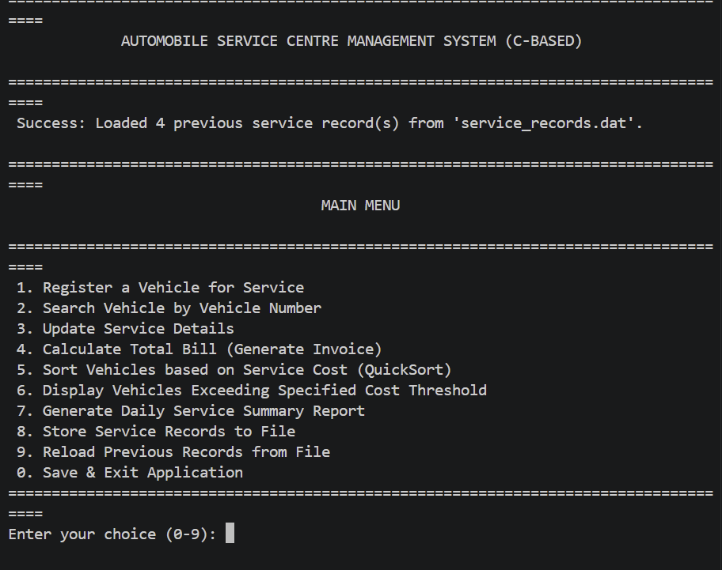
Test Case 2: Successful Registration of Normal Vehicle Service
OUTPUT:
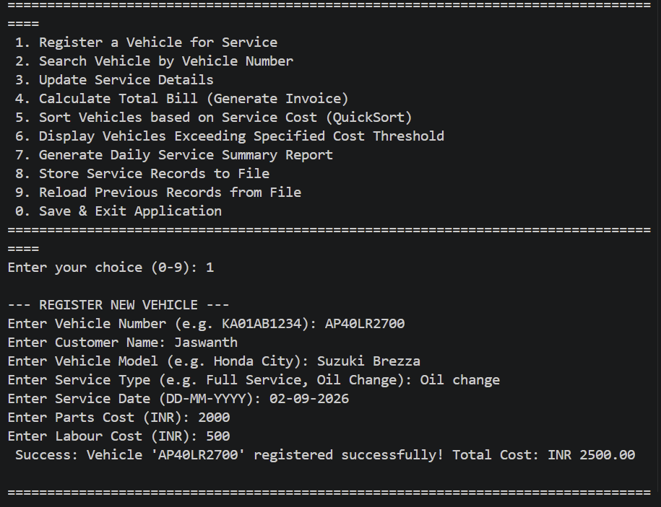

Test Case 3: Registration of High-Cost Engine Repair Service
OUTPUT:

Test Case 4: Searching and Displaying an Existing Vehicle Record
OUTPUT:
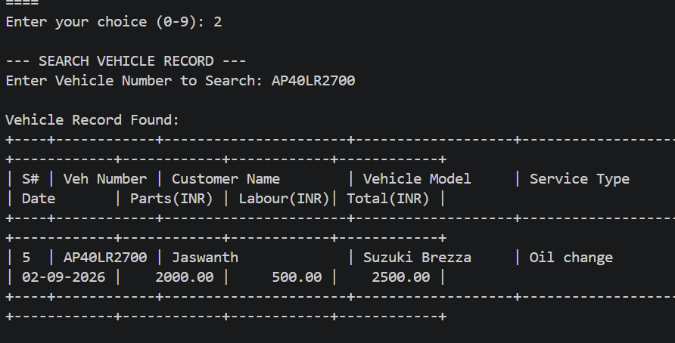
Test Case 5: Updating Service Details Using Pointer to Structure
OUTPUT:
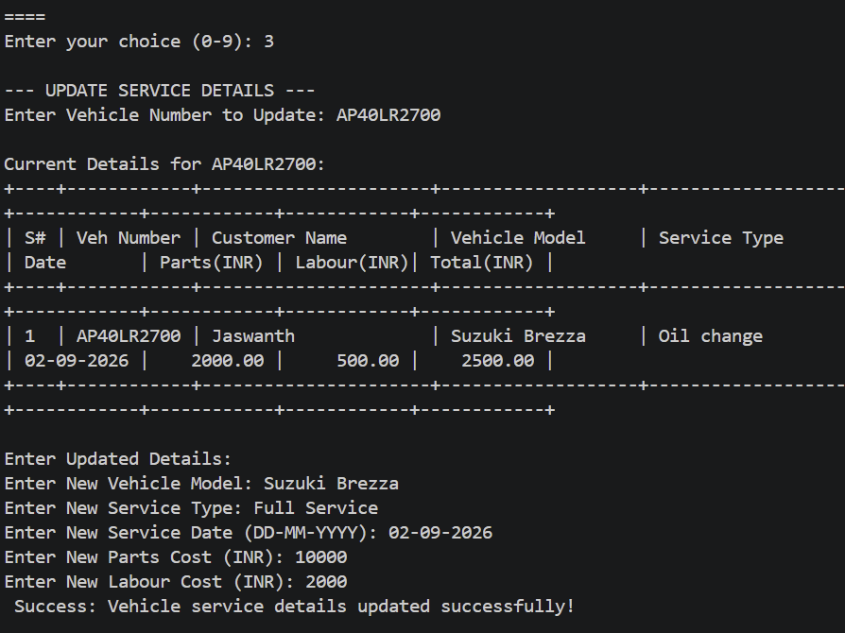
Test Case 6: Vehicles Sorted from Highest to Lowest Service Cost
OUTPUT:
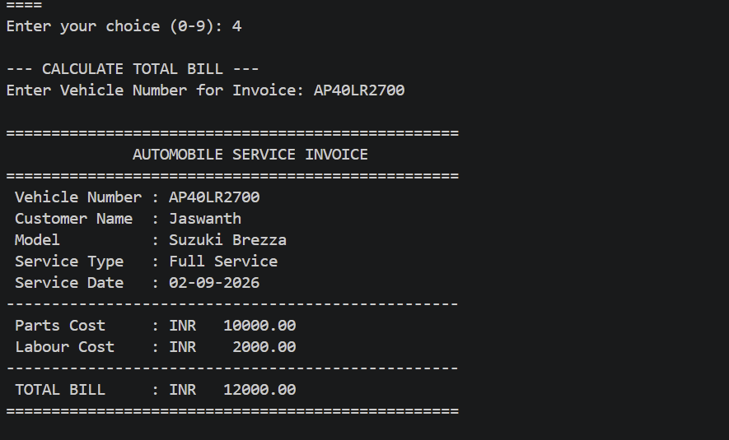
Test Case 7: Displaying Vehicles Above the Specified Service Cost
OUTPUT:

Test Case 8: Daily Service Summary and Total Revenue Calculation
OUTPUT:
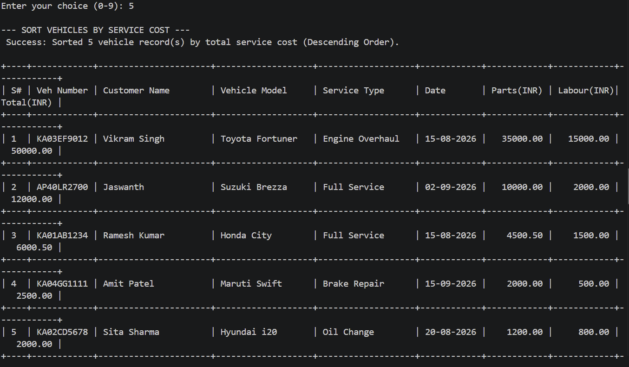
Test Case 9: Loading Previous Service Records When the Program Restarts
OUTPUT:
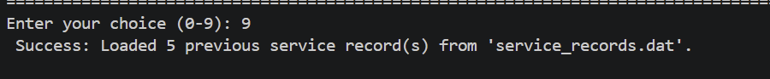

10. Analysis and Discussion
The Automobile Service Centre Management System was developed to demonstrate the practical application of fundamental C programming concepts in a real-world management environment. The system replaces manual service registers with a structured digital solution for storing vehicle details, calculating service costs, searching and updating records, sorting vehicles, generating daily summaries, and maintaining permanent records through file handling. The system was evaluated based on its data structures, pointer usage, searching and sorting algorithms, file management, input validation, error handling, runtime safety, and suitability for the expected number of service records.
Structures were selected as the main data structure because each vehicle service record contains multiple related values of different data types. A record includes the vehicle number, customer name, vehicle model, service type, service date, parts cost, labour cost, and total service cost. Using a structure allows all related information to be grouped into a single service record. An array of structures is used to store multiple vehicle records, making searching, sorting, displaying, and updating easier. The service date is represented using separate day, month, and year values. This makes date validation and comparison easier and allows the system to identify invalid dates and handle leap years correctly. It also supports accurate daily service summaries.
Pointers to structures are used for important operations such as calculating service costs and updating service records. Passing the address of a structure allows functions to directly access and modify the original record without creating unnecessary copies. The arrow operator (->) is used to access structure members through pointers. This approach improves memory efficiency and ensures that changes made during calculations or updates are reflected directly in the stored record. The total service cost is calculated using the formula Total Service Cost = Parts Cost + Labour Cost. Pointer-based functions are particularly useful when updating records stored inside the main array.
The system uses Linear Search to find a vehicle record using its vehicle number. Each record is checked sequentially until the required vehicle is found. Its best-case time complexity is O(1) and worst-case complexity is O(n). Linear Search is suitable for this project because the number of records is limited and the algorithm is simple to implement. However, for thousands of records, techniques such as Binary Search, hash tables, or database indexing would provide better performance.
Insertion Sort is used to arrange vehicles according to their total service cost. It was selected because it is simple, easy to understand, and suitable for small datasets. Its best-case complexity is O(n), while its average and worst-case complexity is O(n²). Since the system has a maximum capacity of around 100 records, the execution time is acceptable. For larger datasets, Quick Sort or Merge Sort would provide better performance. Therefore, Insertion Sort provides a suitable balance between simplicity and performance for the current academic project.
File handling is used to ensure that vehicle records are not lost when the application is closed. The system stores records in a binary file and loads them automatically when the program starts. Functions such as fwrite() and fread() are used to save and retrieve records efficiently. The record count is also maintained so that the program knows how many records need to be loaded. Binary files provide good speed and simple implementation, although they are not easily readable or editable manually. For a large commercial application, a database system would provide better scalability, security, and multi-user access.
Input validation and error handling are important parts of the system. Duplicate vehicle numbers are rejected to maintain unique records, negative service costs are prevented to avoid incorrect billing, and invalid service dates are rejected to ensure accurate daily reports. The system also checks the maximum array capacity before inserting new records, verifies file pointers before reading or writing, checks search results before accessing records, and safely handles invalid menu inputs. These mechanisms follow a defensive programming approach by preventing incorrect user input and unsafe program operations.
Runtime safety was also considered during development. If the maximum number of records is exceeded without checking the limit, the program could access memory outside the allocated array and cause unpredictable behaviour. To prevent this, the system checks the current record count before registering a new vehicle. File operations are also handled safely by checking the result of fopen(). If the file cannot be opened, the file pointer becomes NULL, and performing file operations on it may cause a program crash. Therefore, the system verifies successful file opening before performing read or write operations.
Testing showed that the system performs correctly under both normal and invalid input conditions. Vehicle service records were registered successfully, service costs were calculated correctly, and high-cost services were handled properly. Duplicate vehicle numbers, negative costs, invalid dates, and invalid menu inputs were rejected without terminating the application. Searching, updating, sorting, high-cost filtering, daily summary generation, file saving, and file loading also produced the expected results. These tests demonstrate that the system performs its main operations correctly while safely handling invalid inputs.
The major strength of the system is that it combines several fundamental C programming concepts into one practical application. It demonstrates the use of structures, nested structures, arrays, pointers, functions, searching, sorting, file handling, input validation, and error handling. The menu-driven interface makes the application simple to operate, while the modular function-based design improves readability, maintainability, and testing.
However, the system has certain limitations. The fixed-size array restricts the number of records that can be stored during execution. The application is also designed mainly for a single user and does not provide authentication or access control. Future versions could include GST and discount calculation, customer contact details, mechanic assignment, spare-parts inventory management, invoice generation, service reminders, online booking, database integration, and user authentication. These enhancements would make the system more suitable for real-world service centre operations.
Overall, the selected design is suitable for a small to medium-sized academic application. The chosen data structures and algorithms provide a good balance between simplicity, readability, and functionality. The project successfully demonstrates how a traditional manual service-record system can be converted into a computerized application using C programming concepts. It also highlights that reliable software development requires not only correct functionality but also proper input validation, error handling, runtime safety, and effective management of system resources.
11.Conclusion
The Automobile Service Centre Management System was successfully developed as a C-based application to replace the traditional manual service-register process with a structured computerized solution. The main objective of the project was to manage vehicle service records efficiently while applying important C programming concepts such as structures, pointers, functions, arrays, searching, sorting, file handling, input validation, and error handling.
The system stores complete information for each vehicle, including vehicle number, customer name, vehicle model, service type, service date, parts cost, labour cost, and total service cost. Structures were used to organize this information into meaningful records, while an array of structures allows multiple vehicle records to be managed efficiently. The separate representation of the service date also improves date validation and comparison.
Pointers to structures were effectively used for calculating total service costs and updating service details. By passing the address of a structure to functions, the system can directly access and modify the original service record without unnecessary copying. This demonstrates the practical importance of pointers for efficient data manipulation in C programming.
The menu-driven interface provides essential operations such as vehicle registration, searching, updating service records, calculating bills, sorting records based on service cost, displaying high-cost services, generating daily summaries, saving records to a file, and loading previously stored records when the application starts. These features make the system suitable for managing the basic requirements of an automobile service centre.
The project also gives importance to input validation and error handling. The system prevents duplicate vehicle numbers, rejects negative service costs, validates service dates, checks maximum record capacity, handles invalid menu inputs, verifies file operations, and prevents invalid array access. These features improve the reliability, stability, and safety of the application.
The selected algorithms were evaluated according to the expected number of records. Linear Search and Insertion Sort provide simple and understandable solutions for the current small dataset. Although they may not be efficient for very large datasets, they are appropriate for this academic project because of the limited record capacity and ease of implementation. For future expansion, more efficient algorithms and database systems could be introduced to handle larger numbers of vehicles.
The testing process confirmed that the application performs successfully under normal service conditions, high-cost service conditions, and invalid input situations. All major operations produced the expected results, while incorrect inputs were handled safely without causing program crashes. File handling also ensures that service records remain available after the application is closed and restarted.
In conclusion, the Automobile Service Centre Management System successfully meets the requirements of the project and demonstrates the practical application of C programming concepts in solving a real-world record-management problem. The system provides a strong foundation for future development, with possible enhancements including GST calculation, invoice generation, customer contact management, employee details, spare-parts inventory, authentication, database integration, and graphical user interfaces. These improvements could transform the current academic application into a more advanced and commercially useful service centre management system.
12. References
- E. Balagurusamy, Programming in ANSI C, 8th Edition, McGraw Hill Education, 2019.
- Yashavant Kanetkar, Let Us C, 19th Edition, BPB Publications, 2023.
- Brian W. Kernighan and Dennis M. Ritchie, The C Programming Language, 2nd Edition, Prentice Hall, 1988.
- Herbert Schildt, C: The Complete Reference, 4th Edition, McGraw Hill Education, 2000.
- Reema Thareja, Programming in C, 2nd Edition, Oxford University Press, 2016.
- GNU Compiler Collection (GCC) Documentation, GNU Project. Available at: GCC Documentation
- C Programming Language Documentation, TutorialsPoint. Available at: TutorialsPoint C Programming
- GeeksforGeeks – C Programming Concepts, Structures, Pointers, Searching, Sorting and File Handling. Available at: GeeksforGeeks C Programming
- Microsoft Visual Studio Code Documentation for C programming environment setup and program execution. Available at: Visual Studio Code Documentation
- ISO/IEC 9899:2018 – Programming Languages – C Standard, International Organization for Standardization (ISO).

